YEAR 12 ENGLISH

SEMESTER ONE 2000

Time Allowed For This Paper:

Reading time before commencing this work: 10 minutes
Working time for paper: 3 hours

To be provided by the Supervisor

Questions
Answer Paper

To be provided by the Candidate

Pens, pencils, eraser or correction fluid, ruler.

STRUCTURE OF THIS PAPER

SECTION | YOU SHOULD ANSWER | SUGGESTED WORKING TIME | PROPORTION OF EXAM TOTAL
Comprehension and Comment | All Questions | 50 Minutes | 40
Print  Comment | ONE question from this section | 50 Minutes | 30
Print  Comment | ONE question from this section | 50 minutes | 30

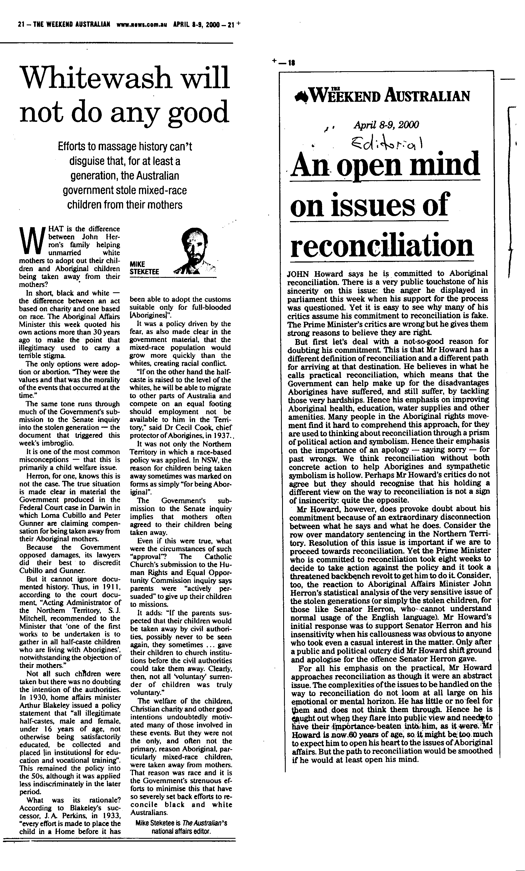
COMPREHENSION AND COMMENT SECTION

ANSWER ALL QUESTIONS. Suggested working time 50 minutes.

Read the passages provided on the previous page and answer the questions below. The passages are taken from the Weekend Australian April 8 – 9 2000.

- What responses towards the Howard Government do the passages encourage? Take into consideration that they appeared in the same edition.

- Discuss the tone and techniques used to present one of the writers views on reconciliation or the stolen generation.

PRINT COMMENT SECTION (Fiction)

Suggested working time 50 minutes.

Choose ONE question to answer.

- Discuss the ways in which setting or location is established in one PRINT text showing how that setting or location contributes to the meaning of the text. Support your answer by referring in detail to the text.

- The structure of texts influences the meaning we construct from them. Discuss how the structure of at least on SHORT STORY or one STAGE DRAMA guides reader responses.

- Enjoyment of fiction reading comes from being challenged. Evaluate this statement by making reference to the issues and values of at least one STAGE DRAMA.

PRINT COMMENT SECTION (Non-Fiction)

Suggested working time 50 minutes.

Choose ONE question to answer.

- FEATURE ARTICLES can act as a barometer for shifts in values in our society. Prepare an argument for this statement making reference to at least one feature article.

- Writers of expository texts often use a variety of techniques to persuade readers to adopt a particular attitude towards an issue. Comment on this statement with reference to at least one EXPOSITORY TEXT.

- Whether fiction or non-fiction, print or non-print, all texts offer a version of reality. The task of the reader is to consider how the writer is using the chosen genre in a particular way. Discuss how the writer of one NON-FICTION PRINT TEXT has constructed meaning.

